Quant Research Meeting
May 29th, 2015 | Location: Conference Room
Agenda

Project Status

- Completed Projects
  - Update Refinancible Percentage Model (Lien)
    - Measure the PMI a borrower is currently paying
    - Capture the Pre-2005 balance using Pool level data
  - Mortgage Rate Difference between Big Lenders and Small Lenders (Lien)
  - New Scale with QuantLib (Bobby)
- Combined Prepay Model and Yield Curve Builder into DLL project structure
- Moved results checking from driver project to library project to avoid settings mismatch(Neo)
- Fixed an error in rates interpolation where the last swap rate exceeds the max curve date duet to day count. Needed to enable extrapolation for the yield curve
- In Progress Projects
  - Accordion - R project for GSE LL data model specification/estimation (Bobby)
    - Productionize Running CRT/STACR deals with eMBS CRT data ~ monthly
    - Knowledge transfer to Lien
  - Baton - R project for Agency Prepayment Modeling (Bobby)
    - Default module
  - Mortgage Rate Differences between Large Lenders and Small Lenders (Lien)
    - Update presentation slides
  - Credit Data Re-Version (Lien)
    - Modify the CRT data query
  - Follow up with YB about the current coupon difference (Lien)
    - YB value from 5/11 to 5/13 is about 0.8 bp higher than Cello’s
  - New Scale with QuantLib (Neo)
- Need to fix another yield curve builder interpolation error that is related to calendar mismatch for USD Libor when using swap rates

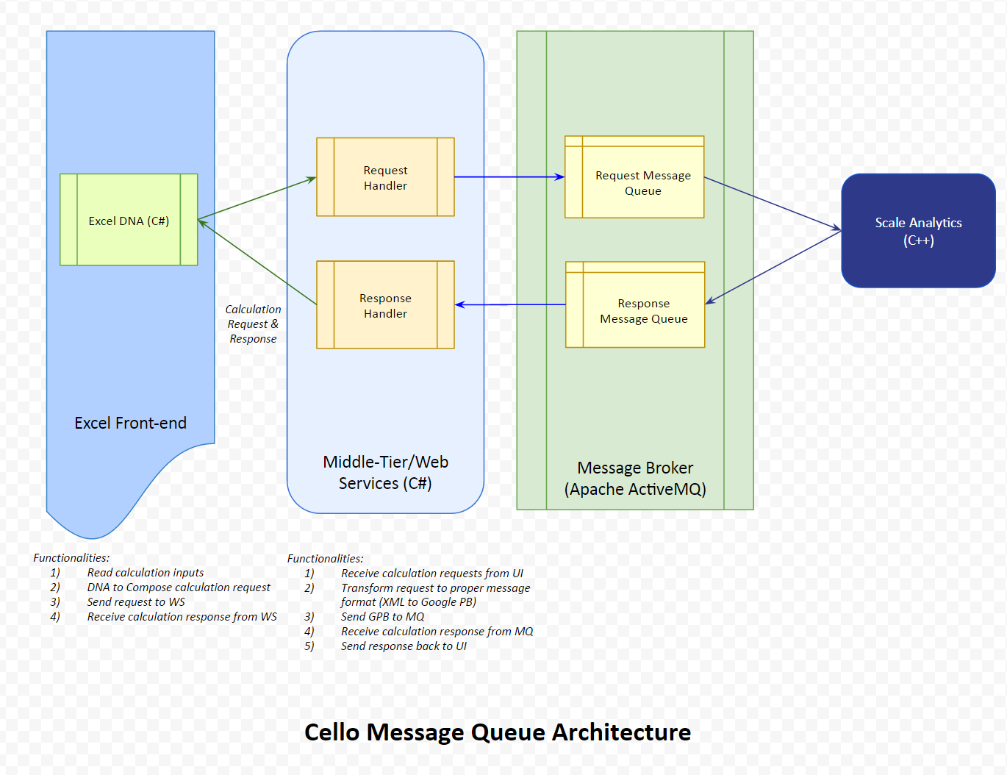

Attendees

Derek Ho, Sharad Chaudhary, Neo Wang, Lien Chen, Robert Morris

